**EE447 EXPERIMENT 2**

**PRELIMINARY REPORT**

Q1-) DELAY.s

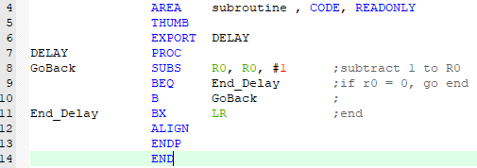

Q2-)__main.s

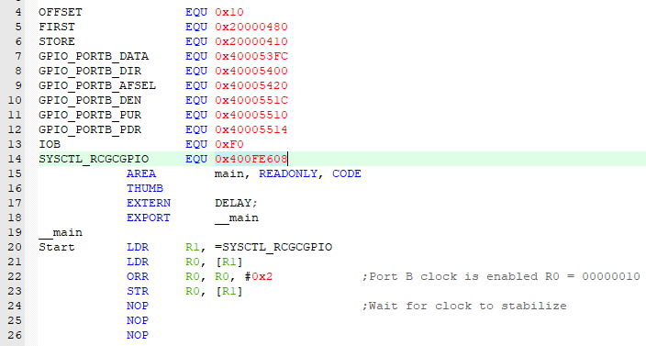

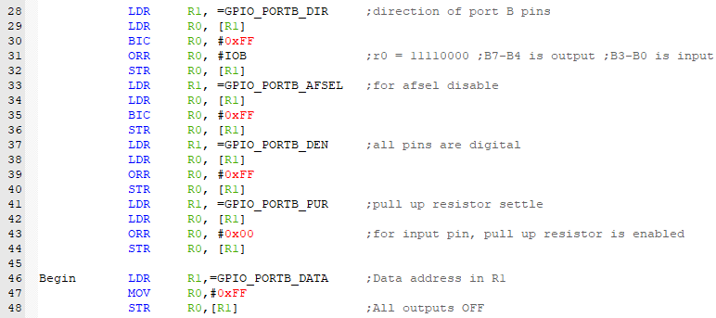

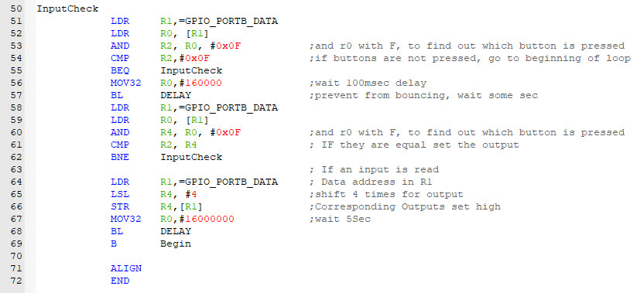

Q3-) a-) we have 4 bits input. If we do not press any button, we give all input value is 1 since we enable the pull up resistor. If we press any button, it gives us 0.

b-) we can compare F after button is pressed. Then, if compare result is 0, we understand button is released.

c-) We give 0 to first row and others is 1. Also, columns are 1 since we enable pull up resistor. Then, if we observe 0 any column, we understand that switch is pressed. For example, we give E for output. That means first column is zero. Then, if we take E from input, first row first column is pressed (K1).

If we take D, K2 is pressed.

d-) We cannot understand exactly which button is pressed. If we add delay, we can avoid bouncing effects.

e-)

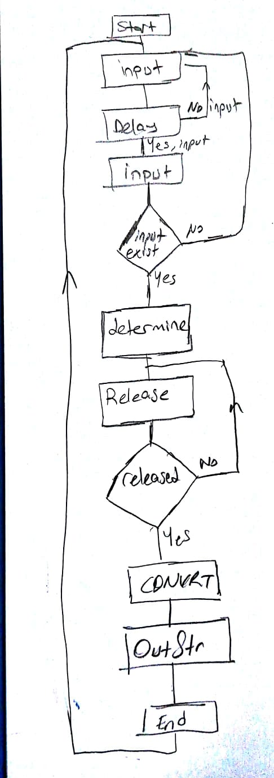

f-)__main.s

